Troubleshooting errors in the IoT Server Room Monitoring device

**IoT Monitoring Device**

Troubleshooting errors

This troubleshooting guide will walk you through errors which you may encounter and how to fix them.  
  
N.B Before beginning troubleshooting ensure that the configuration guide has been complete.

1. The first error you may encounter may be when trying to configure the WiFi on the device  
   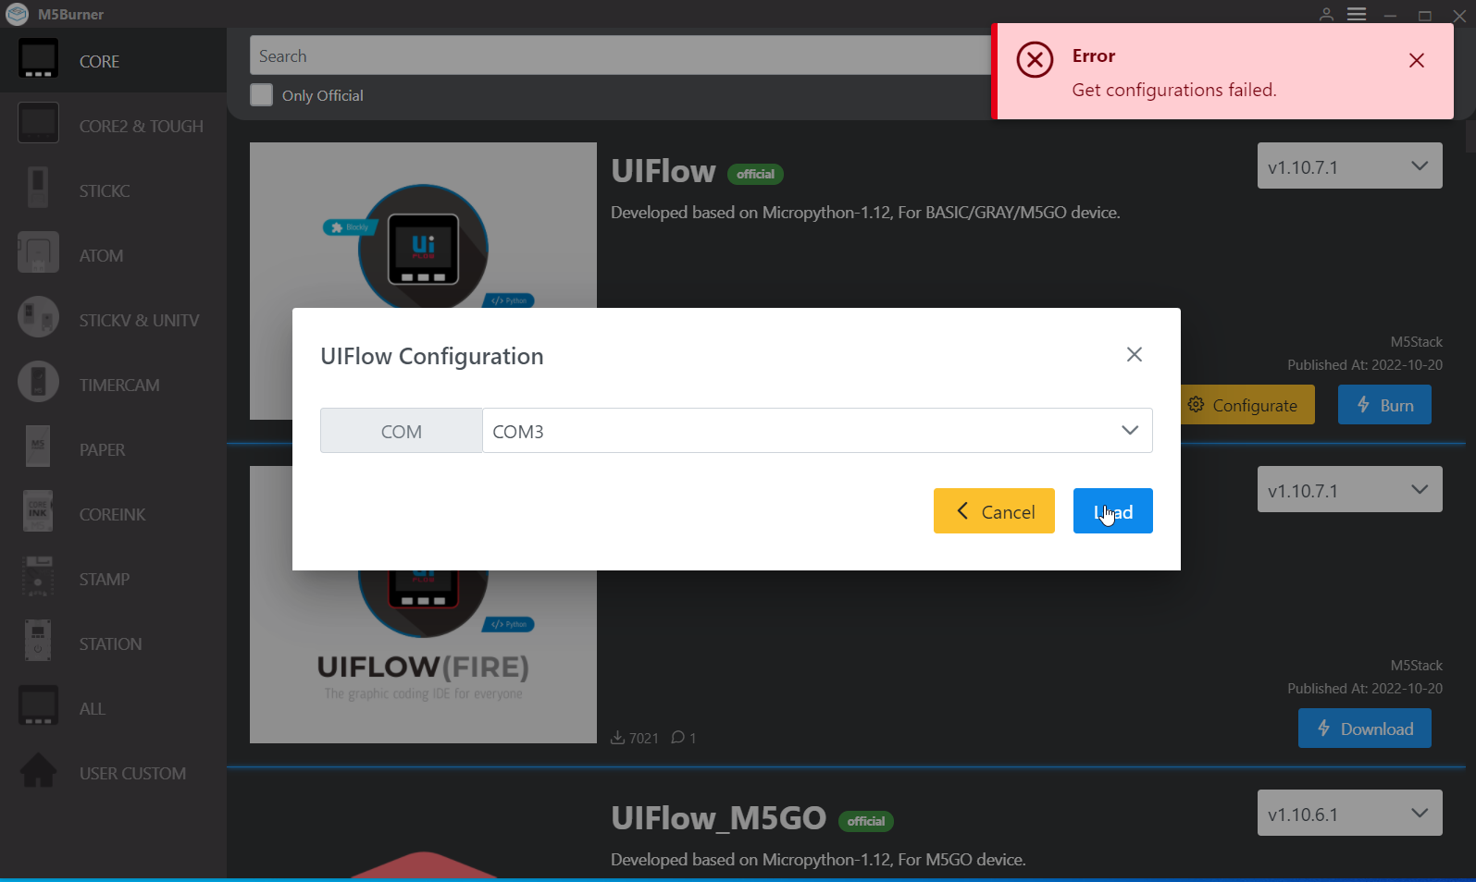
   1. This error arises due to the incorrect COM being choose, to fix this select the correct COM, it may mean selecting each one until one of the COMs work – This error may arise again when burning the config onto the device.
2. An error may be encountered when dropping the code onto the device. This error can occur for three reasons. One, cause the device isn’t connected to the WiFi. Two, the device isn’t powered on. Three, the wrong API key is being used.  
   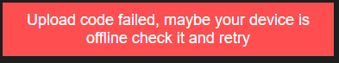
   1. To check whether the device is connected to WiFi, check the device, if it is connected it will have a blue screen which says “Cloud” and the API key.
   2. To check the device is powered on, look at the device screen, if it is blank it is likely turned off, select the button on the left side of the device until the screen turns on. If nothing happens check the device is connected to power and try again.
   3. The API key will be displayed on the screen of the device before the code has been run on it. Enter this API key into the correct field on M5 flow.
3. The M5 device my show a black screen with a red ‘X’ on it. There could be two reasons for this error, the wrong key has been used, or the WiFi hasn’t been configured properly on M5Flow
   1. This is likely to be an issue with the key used in the keyFile field. This should be the private key that is used, if this error appears, use the other key which has been downloaded.  
      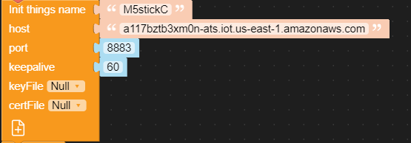
   2. On M5Flow the WiFi SSID and Password need to be configured as the device will continue to check to ensure it is connected to WiFi, if the details are missing or incorrect then the config will fail.  
      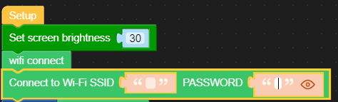
4. No data being returned to IoT SiteWise. This is likely to be a configuration error within IoT sitewise, but device may also not be turned on.  
   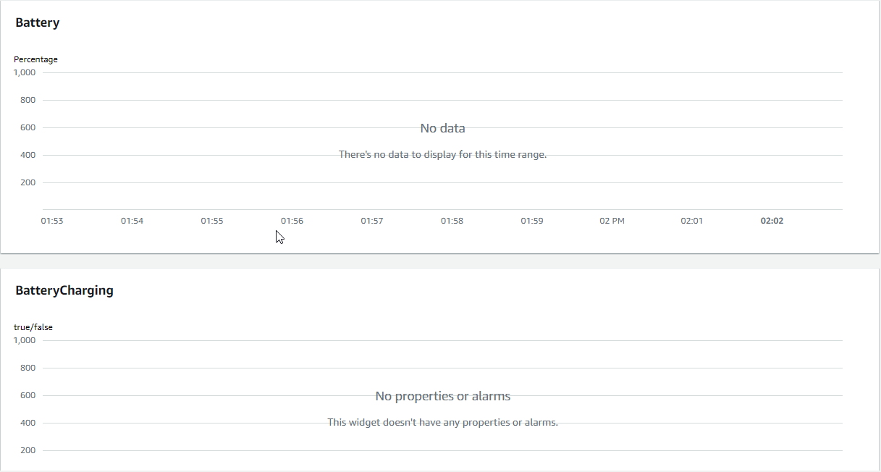
   1. Check the measurement definition alias’ this is likely to be the problem, ensure these follow the correct format and that the correct device name etc has been used. Refer back to guide for correct format.
5. Grafana panel error on dashboard or no data being shown. Can arise from an incorrect Asset or Property value being choose
   1. To fix this ensure that the correct query type is chosen – “Get property value Aggregates”
   2. Ensure that the correct Asset has been chosen – Refer to workbook for this
   3. Ensure that the correct Property has been chosen.